**UNIT-1**

**Worksheet-5**

**Problems related to Equivalence of Finite Automata and Regular Languages and Regular Grammars**

**PART A**

1. Regular expression for all strings starts with ab and ends with bba is.  
a) aba*b*bba  
b) ab(ab)*bba  
c) ab(a+b)*bba  
**d) All of the mentioned**

2. Under which of the following operations, NFA is not closed?  
**a) Negation**  
b) Kleene  
c) Concatenation  
d) None of the mentioned

3. Ragu is asked to make an automaton which accepts a given string for all the occurrences of ‘1001’ in it. How many number of transitions would John use such that the string processing application works?  
a) 9  
b) 11  
c) 12  
d) 15

4**.** Which of the following does not represent the given language? Language: {0,01}  
a) 0+01  
b) {0} U {01}  
c) {0} U {0}{1}  
**d) {0} ^ {01}**

**5.** Which among the following looks similar to the given expression?  
((0+1). (0+1)) *  
a) {xϵ {0,1} *|x is all binary number with even length}  
**b) {xϵ {0,1} |x is all binary number with even length}**  
c) {xϵ {0,1} *|x is all binary number with odd length}  
d) {xϵ {0,1} |x is all binary number with odd length}

**6.** RR* can be expressed in which of the forms:  
**a) R+**  
b) R-  
c) R+ U R-  
d) R

**7.** Which of the following represents a language which has no pair of consecutive 1’s if ∑= {0,1}?  
a) (0+10)*(1+ε)  
b) (0+10)*(1+ε)*  
c) (0+101)*(0+ε)  
d) (1+010)*(1+ε)

**8.** Let the class of language accepted by finite state machine be L1 and the class of languages represented by regular expressions be L2 then  
a) L1<L2  
b) L1>=L2  
c) L1 U L2 = .*  
d) L1=L2

9. Let N (Q, ∑, δ, q0, A) be the NFA recognizing a language L. Then for a DFA (Q’, ∑, δ’, q0’, A’), which among the following is true?  
a) Q’ = P(Q)  
b) Δ’ = δ’ (R, a) = {q ϵ Q | q ϵ δ (r, a), for some r ϵ R}  
c) Q’ = {q0}  
d) All of the mentioned

10. If L1 and L2′ are regular languages, L1 ∩ (L2′ U L1′)’ will be  
a) regular  
b) non regular  
c) may be regular  
d) none of the mentioned

**PART-B**

1. Describe a Regular Expression. Write a Regular Expression for the set of strings that consists of alternating 0’s and 1’s.
2. Examine whether the language L=(0 n 1 n | n>=1) is regular or not? Justify your answer.
3. Construct Finite Automata equivalent to the regular expression (ab+a)*
4. Construct NDFA for given RE using Thomson rule.
5. a(a+b)* ab
6. (a.b)*
7. (a+b)
8. Find the Regular Expression equivalent for the given Finite Automata.

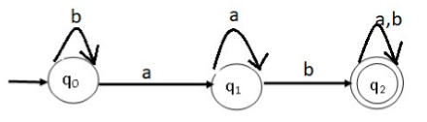

1. Evaluate the equalities for the following RE and prove for the same

(i) b+ab* +aa*b+aa*ab*

(ii) a*(b+ab*).

(iii) a(a+b)*+aa(a+b)*+aaa(a+b)*

1. Find the Regular Expression equivalent for the given Finite Automata.

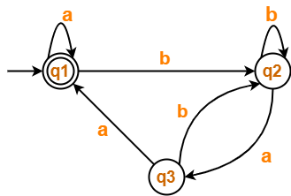

1. Construct a DFA which is equivalent to the following regular expression:

00 ∪ (1 ∪ 01)(11 ∪ 0)∗10 ∗